Service Account

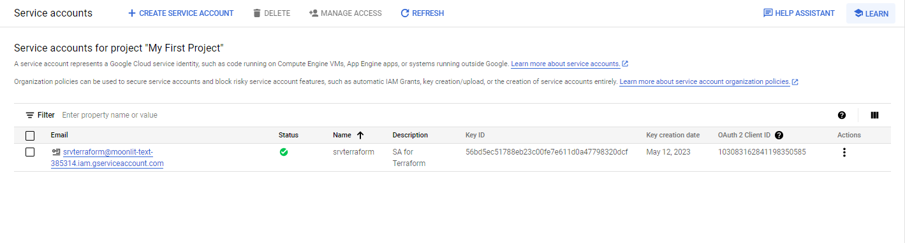

Key

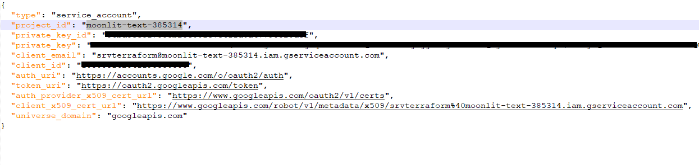

Cloud Resources

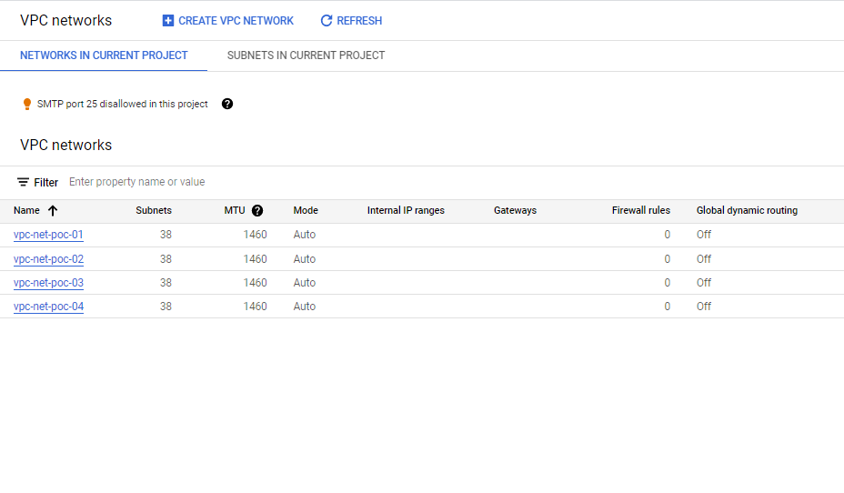

Terraform Scripts

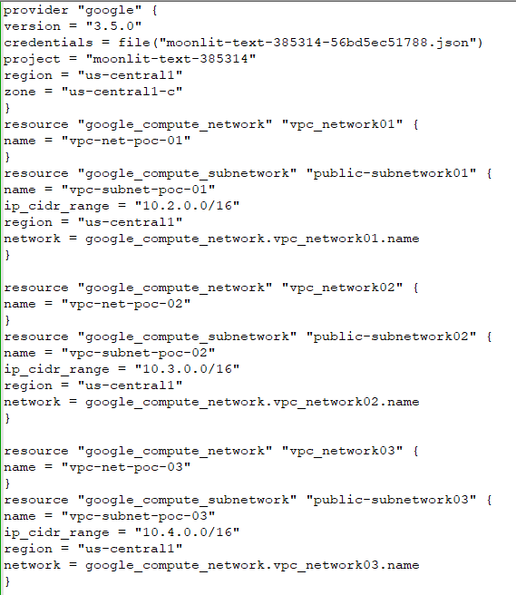

Script Execution

PS D:\cloudguild23\terrform-vpc> .\terraform.exe apply

google_compute_network.vpc_network: Refreshing state... [id=projects/moonlit-text-385314/global/networks/terraform-network]

google_compute_subnetwork.public-subnetwork: Refreshing state... [id=projects/moonlit-text-385314/regions/us-central1/subnetworks/terraform-subnetwork]

Terraform used the selected providers to generate the following execution plan. Resource actions are indicated with the

following symbols:

+ create

- destroy

Terraform will perform the following actions:

# google_compute_network.vpc_network will be destroyed

# (because google_compute_network.vpc_network is not in configuration)

- resource "google_compute_network" "vpc_network" {

- auto_create_subnetworks = true -> null

- delete_default_routes_on_create = false -> null

- id = "projects/moonlit-text-385314/global/networks/terraform-network" -> null

- name = "terraform-network" -> null

- project = "moonlit-text-385314" -> null

- routing_mode = "REGIONAL" -> null

- self_link = "https://www.googleapis.com/compute/v1/projects/moonlit-text-385314/global/networks/terraform-network" -> null

}

# google_compute_network.vpc_network01 will be created

+ resource "google_compute_network" "vpc_network01" {

+ auto_create_subnetworks = true

+ delete_default_routes_on_create = false

+ gateway_ipv4 = (known after apply)

+ id = (known after apply)

+ ipv4_range = (known after apply)

+ name = "vpc-net-poc-01"

+ project = (known after apply)

+ routing_mode = (known after apply)

+ self_link = (known after apply)

}

# google_compute_network.vpc_network02 will be created

+ resource "google_compute_network" "vpc_network02" {

+ auto_create_subnetworks = true

+ delete_default_routes_on_create = false

+ gateway_ipv4 = (known after apply)

+ id = (known after apply)

+ ipv4_range = (known after apply)

+ name = "vpc-net-poc-02"

+ project = (known after apply)

+ routing_mode = (known after apply)

+ self_link = (known after apply)

}

# google_compute_network.vpc_network03 will be created

+ resource "google_compute_network" "vpc_network03" {

+ auto_create_subnetworks = true

+ delete_default_routes_on_create = false

+ gateway_ipv4 = (known after apply)

+ id = (known after apply)

+ ipv4_range = (known after apply)

+ name = "vpc-net-poc-03"

+ project = (known after apply)

+ routing_mode = (known after apply)

+ self_link = (known after apply)

}

# google_compute_network.vpc_network04 will be created

+ resource "google_compute_network" "vpc_network04" {

+ auto_create_subnetworks = true

+ delete_default_routes_on_create = false

+ gateway_ipv4 = (known after apply)

+ id = (known after apply)

+ ipv4_range = (known after apply)

+ name = "vpc-net-poc-04"

+ project = (known after apply)

+ routing_mode = (known after apply)

+ self_link = (known after apply)

}

# google_compute_subnetwork.public-subnetwork will be destroyed

# (because google_compute_subnetwork.public-subnetwork is not in configuration)

- resource "google_compute_subnetwork" "public-subnetwork" {

- creation_timestamp = "2023-05-12T04:22:32.656-07:00" -> null

- gateway_address = "10.2.0.1" -> null

- id = "projects/moonlit-text-385314/regions/us-central1/subnetworks/terraform-subnetwork" -> null

- ip_cidr_range = "10.2.0.0/16" -> null

- name = "terraform-subnetwork" -> null

- network = "https://www.googleapis.com/compute/v1/projects/moonlit-text-385314/global/networks/terraform-network" -> null

- private_ip_google_access = false -> null

- project = "moonlit-text-385314" -> null

- region = "us-central1" -> null

- secondary_ip_range = [] -> null

- self_link = "https://www.googleapis.com/compute/v1/projects/moonlit-text-385314/regions/us-central1/subnetworks/terraform-subnetwork" -> null

}

# google_compute_subnetwork.public-subnetwork01 will be created

+ resource "google_compute_subnetwork" "public-subnetwork01" {

+ creation_timestamp = (known after apply)

+ enable_flow_logs = (known after apply)

+ fingerprint = (known after apply)

+ gateway_address = (known after apply)

+ id = (known after apply)

+ ip_cidr_range = "10.2.0.0/16"

+ name = "vpc-subnet-poc-01"

+ network = "vpc-net-poc-01"

+ project = (known after apply)

+ region = "us-central1"

+ secondary_ip_range = (known after apply)

+ self_link = (known after apply)

}

# google_compute_subnetwork.public-subnetwork02 will be created

+ resource "google_compute_subnetwork" "public-subnetwork02" {

+ creation_timestamp = (known after apply)

+ enable_flow_logs = (known after apply)

+ fingerprint = (known after apply)

+ gateway_address = (known after apply)

+ id = (known after apply)

+ ip_cidr_range = "10.3.0.0/16"

+ name = "vpc-subnet-poc-02"

+ network = "vpc-net-poc-02"

+ project = (known after apply)

+ region = "us-central1"

+ secondary_ip_range = (known after apply)

+ self_link = (known after apply)

}

# google_compute_subnetwork.public-subnetwork03 will be created

+ resource "google_compute_subnetwork" "public-subnetwork03" {

+ creation_timestamp = (known after apply)

+ enable_flow_logs = (known after apply)

+ fingerprint = (known after apply)

+ gateway_address = (known after apply)

+ id = (known after apply)

+ ip_cidr_range = "10.4.0.0/16"

+ name = "vpc-subnet-poc-03"

+ network = "vpc-net-poc-03"

+ project = (known after apply)

+ region = "us-central1"

+ secondary_ip_range = (known after apply)

+ self_link = (known after apply)

}

# google_compute_subnetwork.public-subnetwork04 will be created

+ resource "google_compute_subnetwork" "public-subnetwork04" {

+ creation_timestamp = (known after apply)

+ enable_flow_logs = (known after apply)

+ fingerprint = (known after apply)

+ gateway_address = (known after apply)

+ id = (known after apply)

+ ip_cidr_range = "10.5.0.0/16"

+ name = "vpc-subnet-poc-04"

+ network = "vpc-net-poc-04"

+ project = (known after apply)

+ region = "us-central1"

+ secondary_ip_range = (known after apply)

+ self_link = (known after apply)

}

Plan: 8 to add, 0 to change, 2 to destroy.

╷

│ Warning: Version constraints inside provider configuration blocks are deprecated

│

│ on main.tf line 2, in provider "google":

│ 2: version = "3.5.0"

│

│ Terraform 0.13 and earlier allowed provider version constraints inside the provider configuration block, but that is

│ now deprecated and will be removed in a future version of Terraform. To silence this warning, move the provider

│ version constraint into the required_providers block.

╵

Do you want to perform these actions?

Terraform will perform the actions described above.

Only 'yes' will be accepted to approve.

Enter a value: yes

google_compute_subnetwork.public-subnetwork: Destroying... [id=projects/moonlit-text-385314/regions/us-central1/subnetworks/terraform-subnetwork]

google_compute_network.vpc_network01: Creating...

google_compute_network.vpc_network02: Creating...

google_compute_network.vpc_network04: Creating...

google_compute_network.vpc_network03: Creating...

google_compute_subnetwork.public-subnetwork: Still destroying... [id=projects/moonlit-text-385314/regions/us...tral1/subnetworks/terraform-subnetwork, 10s elapsed]

google_compute_network.vpc_network01: Still creating... [10s elapsed]

google_compute_network.vpc_network04: Still creating... [10s elapsed]

google_compute_network.vpc_network03: Still creating... [10s elapsed]

google_compute_network.vpc_network02: Still creating... [10s elapsed]

google_compute_subnetwork.public-subnetwork: Destruction complete after 16s

google_compute_network.vpc_network: Destroying... [id=projects/moonlit-text-385314/global/networks/terraform-network]

google_compute_network.vpc_network02: Still creating... [20s elapsed]

google_compute_network.vpc_network01: Still creating... [20s elapsed]

google_compute_network.vpc_network03: Still creating... [20s elapsed]

google_compute_network.vpc_network04: Still creating... [20s elapsed]

google_compute_network.vpc_network: Still destroying... [id=projects/moonlit-text-385314/global/networks/terraform-network, 10s elapsed]

google_compute_network.vpc_network03: Still creating... [30s elapsed]

google_compute_network.vpc_network01: Still creating... [30s elapsed]

google_compute_network.vpc_network02: Still creating... [30s elapsed]

google_compute_network.vpc_network04: Still creating... [30s elapsed]

google_compute_network.vpc_network: Still destroying... [id=projects/moonlit-text-385314/global/networks/terraform-network, 20s elapsed]

google_compute_network.vpc_network02: Still creating... [40s elapsed]

google_compute_network.vpc_network04: Still creating... [40s elapsed]

google_compute_network.vpc_network03: Still creating... [40s elapsed]

google_compute_network.vpc_network01: Still creating... [40s elapsed]

google_compute_network.vpc_network: Still destroying... [id=projects/moonlit-text-385314/global/networks/terraform-network, 30s elapsed]

google_compute_network.vpc_network02: Creation complete after 48s [id=projects/moonlit-text-385314/global/networks/vpc-net-poc-02]

google_compute_network.vpc_network01: Creation complete after 48s [id=projects/moonlit-text-385314/global/networks/vpc-net-poc-01]

google_compute_network.vpc_network03: Creation complete after 48s [id=projects/moonlit-text-385314/global/networks/vpc-net-poc-03]

google_compute_network.vpc_network04: Creation complete after 48s [id=projects/moonlit-text-385314/global/networks/vpc-net-poc-04]

google_compute_subnetwork.public-subnetwork03: Creating...

google_compute_subnetwork.public-subnetwork02: Creating...

google_compute_subnetwork.public-subnetwork01: Creating...

google_compute_subnetwork.public-subnetwork04: Creating...

google_compute_network.vpc_network: Still destroying... [id=projects/moonlit-text-385314/global/networks/terraform-network, 40s elapsed]

google_compute_subnetwork.public-subnetwork02: Still creating... [10s elapsed]

google_compute_subnetwork.public-subnetwork03: Still creating... [10s elapsed]

google_compute_subnetwork.public-subnetwork01: Still creating... [10s elapsed]

google_compute_subnetwork.public-subnetwork04: Still creating... [10s elapsed]

google_compute_subnetwork.public-subnetwork04: Creation complete after 16s [id=projects/moonlit-text-385314/regions/us-central1/subnetworks/vpc-subnet-poc-04]

google_compute_subnetwork.public-subnetwork03: Creation complete after 16s [id=projects/moonlit-text-385314/regions/us-central1/subnetworks/vpc-subnet-poc-03]

google_compute_subnetwork.public-subnetwork01: Creation complete after 16s [id=projects/moonlit-text-385314/regions/us-central1/subnetworks/vpc-subnet-poc-01]

google_compute_subnetwork.public-subnetwork02: Creation complete after 17s [id=projects/moonlit-text-385314/regions/us-central1/subnetworks/vpc-subnet-poc-02]

google_compute_network.vpc_network: Still destroying... [id=projects/moonlit-text-385314/global/networks/terraform-network, 50s elapsed]

google_compute_network.vpc_network: Destruction complete after 57s

Apply complete! Resources: 8 added, 0 changed, 2 destroyed.